ESTIMATRIX-PREDICTING PROJECT COSTS AND TIMELINE
U23CB652-  INNOVATIVE  PROJECT |  | U23CB652 - INNOVATIVE / MULTI-DISCIPLINARY PROJECT REPORT  SUBMITTED IN PARTIAL FULFILLMENT OF THE REQUIREMENTS FOR THE AWARD OF THE  DEGREE OF BACHELOR OF TECHNOLOGY  IN COMPUTER SCIENCE AND BUSINESS SYSTEMS  OF THE ANNA UNIVERSITY
April / May 2026 |  | 22
PROJECT  WORK  BATCH  2023 – 2027 |  | Submitted by  ADRIANNAA ANAND - 722823244001  ARAVINDH G - 722823244005  DHARSHINI N - 722823244013  VAISHNAV P V - 722823244057  Under the Guidance of  Dr. K. Cholaraja, MTech., Ph.D.,  Assistant Professor  Computer Science and Business Systems
 | Sri Eshwar College of Engineering  (An Autonomous Institution)  Kinathukadavu (Tk), Coimbatore - 641 202, Tamil Nadu  Approved by AICTE, New Delhi and Affiliated to Anna University, Chennai |  | 



BONAFIDE CERTIFICATE

Certified that this Report titled “ESTIMATRIX-PREDICTING PROJECT COSTS AND TIMELINE” is the
Bonafide work of

ADRIANNAA ANAND | 722823244001
ARAVINDH G | 722823244005
DHARSHINI N | 722823244013
VAISHNAV P V | 722823244057

who carried out the project work under my supervision.

SIGNATURE SIGNATURE

Dr. PL. Rajarajeshwari M.E., Ph.D.,

HEAD OF THE DEPARTMENT
Computer Science and Business Systems, Sri Eshwar College of Engineering, Coimbatore – 641 202.
Dr. K. Cholaraja, MTech., Ph.D.,

SUPERVISOR
ASSISTANT PROFESSOR,
Computer Science and Business Systems, Sri Eshwar College of Engineering, Coimbatore – 641 202.

Submitted for the Autonomous End Semester Innovative / Multi-Disciplinary Project Viva-Voce held on ………………….

INTERNAL EXAMINER EXTERNAL EXAMINER



QUALITY POLICY
To establish a system of Quality Enhancement, which would on a continuous basis evaluate and enhance the quality of teaching – learning, research and extension activities of the institution, leading to improvements in all processes, enabling the institution to attain excellence.

INSTITUTE VISION
To be recognized as a premier institution, grooming students into globally acknowledged engineering professionals.

INSTITUTE MISSION
- Providing outcome and value-based engineering education
- Nurturing research and entrepreneurial culture
- Enabling students to be industry ready and fulfill their career aspirations
- Grooming students through behavioral and leadership training programs
- Making students socially responsible

DEPARTMENT OF COMPUTER SCIENCE AND BUSINESS SYSTEMS
DEPARTMENT VISION
To become a Centre of excellence in Software Engineering and Business Systems domains and evolve as an integrated facility in providing academic services that drive research and innovation, leading to industry advancements that serve society.

DEPARTMENT MISSION

- Develop a curriculum that meets the evolving demands of the industry, integrating inventive teaching approaches for comprehensive education.
- Provide professional development opportunities for faculty members to enhance their expertise in IT and Management courses.
- Promote connections with stakeholders to encourage the sharing, utilization, and exchange of managerial expertise.
- Initiate community-based activities that apply managerial expertise to effectively address societal issues.
- Build and upgrade facilities to ensure the delivery of modern IT and management education.

PROGRAM EDUCATIONAL OBJECTIVES
PEO1: Pursue careers in IT and management specializations offered by institutions, utilizing the essential core competencies gained within an assessment-focused learning environment.
PEO2: Graduates will enroll in a postgraduate program focused on Information Technology and Management Sciences, paying the way for academic and research -oriented career path.
PEO3: Graduates will embark on an entrepreneurial path for their careers.

PROGRAM OUTCOMES
PO1: Engineering Knowledge: Apply knowledge of mathematics, natural science, computing, engineering fundamentals and an engineering specialization as specified in WK1 to WK4 respectively to develop to the solution of complex engineering problems.
PO2: Problem Analysis: Identify, formulate, review research literature and analyze complex engineering problems reaching substantiated conclusions with consideration for sustainable development. (WK1 to WK4)
PO3: Design/Development of Solutions: Design creative solutions for complex engineering problems and design/develop systems/components/processes to meet identified needs with consideration for the public health and safety, whole-life cost, net zero carbon, culture, society and environment as required. (WK5)
PO4: Conduct Investigations of Complex Problems: Conduct investigations of complex engineering problems using research-based knowledge including design of experiments, modelling, analysis & interpretation of data to provide valid conclusions. (WK8).
PO5: Engineering Tool Usage: Create, select and apply appropriate techniques, resources and modern engineering & IT tools, including prediction and modelling recognizing their limitations to solve complex engineering problems. (WK2 and WK6)
PO6: The Engineer and The World: Analyze and evaluate societal and environmental aspects while solving complex engineering problems for its impact on sustainability with reference to economy, health, safety, legal framework, culture and environment. (WK1, WK5, and WK7).
PO7: Ethics: Apply ethical principles and commit to professional ethics, human values, diversity and inclusion; adhere to national & international laws. (WK9)
PO8: Individual and Collaborative Team work: Function effectively as an individual, and as a member or leader in diverse/multi-disciplinary teams.
PO9: Communication: Communicate effectively and inclusively within the engineering community and society at large, such as being able to comprehend and write effective reports and design documentation, make effective presentations considering cultural, language, and learning differences

PO10: Project Management and Finance: Apply knowledge and understanding of engineering management principles and economic decision-making and apply these to one’s own work, as a member and leader in a team, and to manage projects and in multidisciplinary environments.
PO11: Life-Long Learning: Recognize the need for, and have the preparation and ability for
I) independent and life-long learning ii) adaptability to new and emerging technologies and iii) critical thinking in the broadest context of technological change. (WK8)

PROGRAM SPECIFIC OUTCOMES

PSO1: To employ suitable methodologies, advanced tools, and modern engineering and business technologies, including prediction and data analytics, for addressing complex engineering tasks and business challenges.
PSO2: To evolve Computer Science domain-specific techniques and approaches to support and enhance decision-making across diverse domains, including business processes and beyond.

DECLARATION

We,

ADRIANNAA ANAND [722823244001] ARAVINDH G [722823244005] DHARSHINI N [722823244013]
VAISHNAV P V [722823244057]

Declare that the project entitled “ESTIMATRIX-PREDICTING PROJECT COSTS AND TIMELINE”, submitted in partial fulfilment to Anna University as the project work of Bachelor of Technology (Computer Science and Business Systems) Degree, is a record of original work done by us under the supervision and guidance of Dr. K. Cholaraja, MTech., Ph.D., Assistant Professor of CSBS, Sri Eshwar College of Engineering, Coimbatore.

Place: Coimbatore Date:
[ADRIANNAA ANAND]

[ARAVINDH G]

[DHARSHINI N]

[VAISHNAV P V]

Project Guided by

[Dr. K. Cholaraja, MTech., Ph.D., AP/CSBS]

ACKNOWLEDGEMENT

ACKNOWLEDGEMENT

The success of a work depends on a team and cooperation. We take this opportunity to express our gratitude and thanks to everyone who helped us with our project. We would like to thank the management for the constant support provided to them to complete this project.
It is indeed our great honor bounded duty to thank our beloved Chairman Mr. R. Mohanram, for his academic interest shown towards the students. We are indebted to our Director Mr. R. Rajaram, for motivating and providing us with all facilities.
We wish to express our sincere regards and a deep sense of gratitude to dear Dr. Sudha Mohanram, M.E, Ph.D., Principal, for the excellent facilities and encouragement provided during the course of the study and project.
We are indebted to our internal project Guide Dr. K. Cholaraja, MTech., Ph.D., Assistant Professor of Computer Science and Business Systems for having permitted us to carry out this project and giving us the complete freedom to utilize the resources of the department and also providing us her support and guidance which really helped us.
We express our sincere thanks to our project Co-coordinator Dr. A. Sandana Karuppan M.E., PhD., Associate Professor, Department of Computer Science and Business Systems for his valuable guidance and encouragement given to us for this project.
We solemnly express our thanks to all the teaching and non-teaching staff of the Computer Science and Business Systems Department, family, and friends for their valuable support which inspired us to work on this project.

TABLE OF CONTENT

CHAPTER NO. | TITLE |  | PAGE NO.
 | ABSTRACT |  | i
 | LIST OF FIGURES |  | ii
1 | INTRODUCTION
 | 1.1 | OBJECTIVES | 1
 | 1.2 | SCOPE OF THE PROJECT | 2
2 | SYSTEM ANALYSIS AND SPECIFICATION
 | 2.1 | PROBLEM DESCRIPTION | 3
 | 2.2 | FUNCTIONAL REQUIREMENT - HARDWARE & SOFTWARE | 3
 | 2.3 | NON – FUNCTIONAL REQUIREMENT | 4
3 | PROPOSED SOLUTION AND FLOWCHART
 | 3.1 | PROPOSED SOLUTION | 6
 | 3.2 | FLOWCHART DIAGRAM | 7
4 | MODULE DESCRIPTION |  | 8
5 | IMPLEMENTATION |  | 10
6 | RESULTS AND DISCUSSION |  | 12
7 | CONCLUSION & FUTURE ENHANCEMENT |  | 14
 | REFERENCES |  | 16

ABSTRACT

In the current landscape of project management, organizations frequently encounter significant challenges related to cost overruns and timeline delays. Existing estimation approaches rely heavily on manual methods, expert judgment, and static spreadsheet-based tools that fail to adapt to dynamic project conditions. To address these challenges, ESTIMATRIX is proposed as an advanced AI-powered predictive system that leverages machine learning algorithms to accurately estimate project cost and timeline based on historical and real-time project data.
ESTIMATRIX analyzes critical project factors including project scope, team size, resource allocation, task dependencies, risk factors, and past project performance to deliver precise predictions. The system supports multiple project types such as software development and construction projects, and continuously learns from new data to improve its accuracy over time. A key feature of the system is its confidence-level reporting, which provides stakeholders with the reliability measure of each prediction alongside a risk assessment summary.
The platform includes a user-friendly dashboard for inputting project parameters, interactive visualizations for comparing estimated versus actual values, scenario analysis for exploring what-if situations, and automated alerts for high-risk projects. Output includes estimated cost range, estimated timeline range, risk assessment summary, and key influencing variables. Built using modern technologies including Python, React.js, Flask, and scikit-learn, ESTIMATRIX provides a scalable and intelligent solution that transforms project planning into a data-driven and proactive experience.
Keywords: Machine Learning, Project Cost Estimation, Timeline Prediction, Risk Assessment, Predictive Analytics, Scenario Analysis, Dashboard, Historical Data, Resource Allocation, Confidence Intervals.

 | LIST OF FIGURES
Fig No | TITLE | PAGE NO
3.1 | FLOWCHART DIAGRAM | 4
6.1 | DASHBOARD | 12

CHAPTER 1 INTRODUCTION

  - OBJECTIVES

The primary objective of ESTIMATRIX is to design and develop an intelligent predictive system that accurately estimates project cost and completion time by leveraging machine learning algorithms and comprehensive historical data analysis. The system aims to eliminate the inefficiencies of traditional estimation methods by providing automated, data-driven predictions that adapt continuously based on new project outcomes.
A key objective is to implement machine learning models capable of analyzing multi-dimensional project attributes including scope complexity, team size, resource allocation, task dependencies, and past performance metrics. The system is designed to handle diverse project types including software development, construction, and manufacturing, making it versatile for cross-domain applications.
The project further aims to provide confidence levels for each prediction, enabling project managers to assess the reliability of estimates before committing to timelines and budgets. An important objective is to identify and highlight key factors contributing to cost overruns and timeline delays, thereby enabling proactive corrective measures.
Additionally, ESTIMATRIX seeks to include a risk assessment module that automatically categorizes projects as low, medium, or high risk based on detected patterns. The system incorporates a scenario analysis feature, allowing stakeholders to simulate different resource configurations and predict their impact on project outcomes. Automated alerts are integrated to flag high-risk projects for immediate attention.
From a user experience perspective, the objective is to provide an intuitive dashboard that simplifies parameter input, displays real-time predictions, and presents interactive visualizations comparing estimated versus actual values. The overall goal is to create a scalable, continuously learning platform that improves prediction accuracy over time and supports smarter, evidence-based project planning.
.

  - SCOPE OF THE PROJECT
The system encompasses a broad range of functionalities including data ingestion from historical project records, automated feature extraction, model training, and prediction generation for cost and timeline. Users can input project parameters through a structured dashboard and receive immediate predictions accompanied by confidence levels and risk assessments. The scope includes support for multiple project types such as software development, construction, and research projects, ensuring broad applicability.
A significant aspect of the scope is the continuous learning mechanism, where the system retrains its models as new project completion data becomes available. This ensures that predictions remain accurate and reflect evolving organizational patterns. The scope also covers scenario simulation, enabling users to adjust parameters such as team size or budget allocation and observe the predicted effect on project outcomes.
The system further includes risk identification modules that analyze patterns in historical overruns and flag similar patterns in ongoing projects. Automated alert notifications are triggered for high-risk scenarios. Visualization features such as graphs and comparison charts provide stakeholders with intuitive insights into prediction accuracy and key influencing variables.
However, the current implementation focuses on structured project data and does not extend to real-time external data feeds or enterprise-level ERP integrations. Future enhancements may expand the platform to support integration with project management tools such as Jira and MS Project, as well as cloud-based deployment for large-scale institutional use

CHAPTER 2
SYSTEM ANALYSIS AND SPECIFICATION

  - PROBLEM DESCRIPTION
In modern project management environments, accurate cost and timeline estimation is critical to organizational success, yet most existing approaches rely heavily on expert intuition, manual calculations, and static spreadsheet models that fail to adapt to the dynamic and complex nature of real-world projects. As a result, organizations often experience cost overruns, schedule delays, and inefficient resource allocation, leading to financial losses and stakeholder dissatisfaction. A major issue is the lack of data-driven decision support, despite the availability of large volumes of historical project data that remain underutilized for predictive insights. Furthermore, current methods struggle to account for multiple interacting variables such as team composition, task dependencies, risk factors, and market fluctuations, all of which significantly influence project outcomes. Another limitation is the absence of confidence indicators, leaving managers uncertain about the reliability of their estimates, along with the lack of scenario simulation capabilities that prevent exploration of alternative strategies without extensive manual effort. Additionally, existing tools do not provide automated risk alerts, making it difficult to identify and address potential issues early. These challenges highlight the need for an advanced, integrated solution like ESTIMATRIX, which leverages machine learning to generate dynamic, data-driven predictions with confidence levels while enabling proactive risk management through visualization and scenario analysis.

  - FUNCTIONAL REQUIREMENT
Functional requirements define the core functionalities and operations that the LURNIX
system must perform to meet user needs effectively.
- Hardware Requirements
ESTIMATRIX requires standard computing infrastructure for deployment. A server or computing device with a minimum of 8 GB RAM and a multi-core processor is recommended for model training and prediction serving. For end-users accessing the dashboard, devices with 4 GB RAM and stable internet connectivity are sufficient.

- Software Requirements
The ESTIMATRIX platform is developed using a modern technology stack to ensure performance, scalability, and maintainability. The backend is implemented using Python with Flask to handle API endpoints and business logic. Machine learning models are built using scikit-learn and XGBoost for regression and classification tasks. The frontend dashboard is developed using React.js with Tailwind CSS for a responsive and intuitive user interface. Data storage is managed through a PostgreSQL database for structured project records, while pandas and NumPy are used for data preprocessing and feature engineering. Visualization components are implemented using Chart.js and Plotly for interactive graphs and comparison charts. The system operates on standard web browsers, requiring no additional installations for end-users.

  - NON-FUNCTIONAL REQUIREMENT
Non-functional requirements define the quality attributes and performance standards of the ESTIMATRIX system, ensuring reliability, usability, and scalability.
Performance: The system must provide fast prediction responses, typically within 2–3 seconds of parameter submission. Model training operations are executed asynchronously to avoid impacting the user experience.

Scalability: The platform must support an increasing volume of historical project records and concurrent user sessions without performance degradation. The modular ML pipeline allows for easy model updates and feature additions.

Usability: The system must provide a user-friendly dashboard that enables non-technical project managers to input parameters, interpret predictions, and explore scenario analyses without requiring data science expertise.

Reliability: All prediction modules, risk assessment components, and alert systems must operate consistently. Model validation mechanisms ensure that only accurately trained models are deployed for production predictions.

Security: Project data, including sensitive cost and resource information, must be protected using secure API communication (HTTPS) and role-based access control. Authentication is implemented using JWT tokens.

Maintainability: The system is designed with a modular architecture, ensuring that individual ML models, API endpoints, and UI components can be updated or replaced independently without disrupting overall functionality.

Compatibility: The platform is compatible with major web browsers including Google Chrome, Mozilla Firefox, and Microsoft Edge, ensuring accessibility across diverse user environments.

CHAPTER 3
PROPOSED SOLUTION AND SYSTEM DESIGN

- PROPOSED SOLUTION
To overcome the limitations of traditional project estimation methods, ESTIMATRIX is proposed as an integrated, AI-powered predictive system that leverages machine learning on historical and real-time project data to deliver accurate cost and timeline estimates, replacing guesswork with data-driven insights. At its core, the system features a Machine Learning Prediction Engine trained on datasets containing project scope, team size, resource allocation, task dependencies, risk indicators, and actual outcomes, using regression models for cost and time prediction and classification techniques for risk assessment, with adaptability across domains such as software development and construction through project-specific configurations. Complementing this, a Confidence Level Reporting Module provides reliability scores for each prediction based on similarity to historical patterns, enabling stakeholders to make informed decisions with appropriate caution. The Risk Assessment Module evaluates input variables against historical trends to classify projects into low, medium, or high risk, supported by an automated alert system for early intervention, while the Key Variable Analysis component highlights the most influential factors affecting deviations. For strategic decision-making, the Scenario Analysis Module allows users to adjust parameters like team size, budget, or scope and instantly observe predicted impacts, facilitating better resource planning. Additionally, a Continuous Learning Module ensures ongoing model improvement by retraining with new project data, keeping predictions relevant and accurate, and an intuitive User Dashboard integrates all functionalities, offering parameter input, visualization of predictions versus actual outcomes, and access to risk and scenario insights, making ESTIMATRIX a comprehensive, scalable, and intelligent solution for modern project planning.

- FLOWCHART DIAGRAM 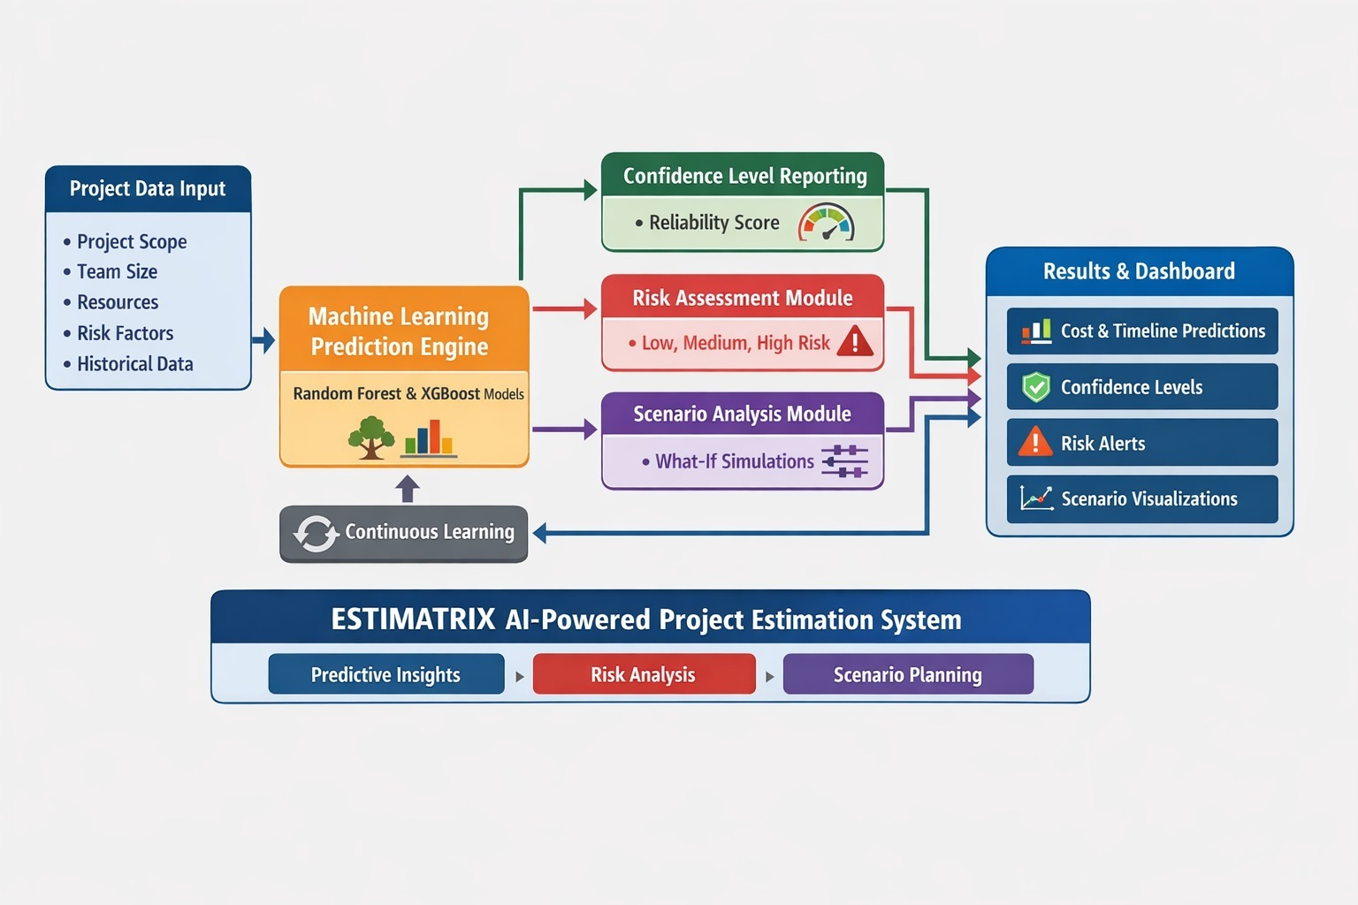 Fig 3.1 FLOWCHART DIAGRAM

CHAPTER 4

MODULE DESCRIPTION
The ESTIMATRIX platform is designed as a modular system where each module performs a specialized function to provide an integrated and accurate project estimation experience. The major modules of the system are described below:

4.1 User Authentication Module
This module manages user registration, login, and session management. It ensures secure access to the platform using JWT-based authentication and supports role-based access control for project managers, analysts, and administrators.

4.2 Data Ingestion and Preprocessing Module
This module handles the ingestion of historical project records from CSV files or database sources. It performs data cleaning, normalization, and feature engineering to prepare the dataset for machine learning model training.

4.3 Machine Learning Prediction Engine
This is the core module responsible for training and deploying regression models (such as Random Forest and XGBoost) to predict total project cost and completion time. It supports project-type-specific model configurations to improve domain-specific accuracy.

4.4 Confidence Level Reporting Module
This module calculates and reports the confidence level associated with each prediction. It uses statistical measures and model uncertainty estimation to provide stakeholders with a reliability score that reflects how closely the input resembles historical training data.

4.5 Risk Assessment Module
This module analyzes project parameters and historical overrun patterns to classify the risk level of each project as low, medium, or high. It generates a detailed risk assessment summary highlighting the primary risk contributors.

4.6 Alert and Notification Module
This module monitors prediction outputs and automatically triggers alerts for projects classified as high risk. Notifications are delivered via the dashboard and optionally via email, ensuring that project managers are informed of critical risks promptly.

4.7 Key Variable Analysis Module
This module identifies and ranks the most influential factors affecting the predicted cost and timeline. It uses feature importance scores from the trained models to highlight variables such as team size, scope changes, or resource shortages as primary drivers of project deviations.

4.8 Scenario Analysis Module
This module enables users to perform what-if analyses by modifying input parameters such as team size, budget allocation, or project scope. It instantly re-runs the prediction engine with the modified parameters and displays the updated cost and timeline forecasts.

4.9 Continuous Learning Module
This module periodically retrains the prediction models as new project completion records are added to the system. It ensures that ESTIMATRIX adapts to changing organizational patterns and maintains prediction accuracy over time.

4.10 Visualization and Dashboard Module
This module provides an interactive user dashboard for parameter input, prediction display, and data visualization. It includes charts comparing estimated versus actual values, risk distribution graphs, trend analysis views, and scenario comparison panels.

Overall, the modular structure of ESTIMATRIX ensures flexibility, scalability, and efficient integration of diverse machine learning and project management capabilities within a single platform.

CHAPTER 5
IMPLEMENTATION
Sample Code:
import { motion } from "framer-motion";
import { ReactNode } from "react";
import { LucideIcon } from "lucide-react";

interface StatCardProps {
title: string;
value: string;
subtitle?: string;
icon: LucideIcon;
variant?: "default" | "primary" | "accent" | "success" | "danger";
delay?: number;
}

const variantStyles = {
default: "bg-card shadow-card",
primary: "gradient-primary text-primary-foreground",
accent: "gradient-accent text-accent-foreground",
success: "gradient-success text-accent-foreground",
danger: "gradient-risk text-accent-foreground",
};

const iconBg = {
default: "bg-muted",
primary: "bg-primary-foreground/20",
accent: "bg-accent-foreground/20",
success: "bg-accent-foreground/20",
danger: "bg-accent-foreground/20",
};

export function StatCard({ title, value, subtitle, icon: Icon, variant = "default", delay = 0 }: StatCardProps) {
return (
<div className="flex items-start justify-between">
<div>
<p className={`text-xs font-medium uppercase tracking-wider ${variant === "default" ? "text-muted-foreground" : "opacity-80"}`}>
{title}
</p>
)}
</div>
<div className={`w-10 h-10 rounded-lg flex items-center justify-center ${iconBg[variant]}`}>
<Icon className="w-5 h-5" />
</div>
</div>
</motion.div>
);
}

CHAPTER 6
RESULTS AND DISCUSSIONS

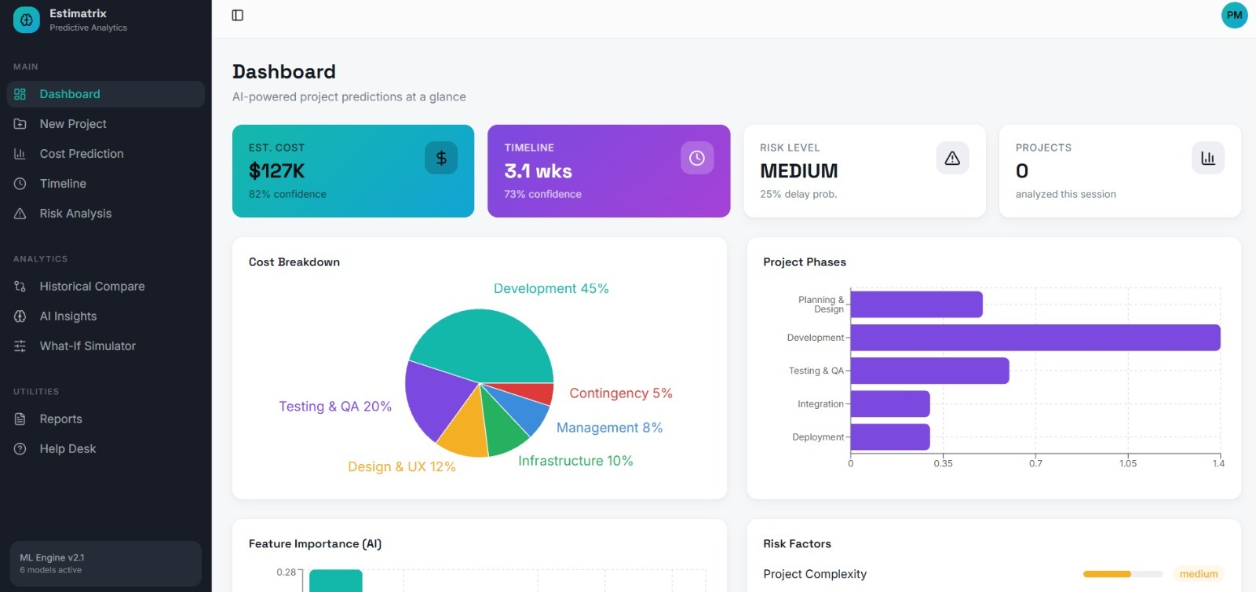
Fig 6.1 DASHBOARD

RESULT & DISCUSSION:
The ESTIMATRIX platform was successfully developed and evaluated as an integrated AI-powered project estimation system, offering a user-friendly dashboard where project managers can input key parameters and instantly receive cost and timeline predictions along with confidence levels and risk assessments. The Machine Learning Prediction Engine, trained on diverse historical project datasets from domains such as software development and construction, utilized Random Forest and XGBoost regression models to achieve strong predictive accuracy, with a mean absolute percentage error (MAPE) of approximately 8–12%, demonstrating reliable estimation performance. The Confidence Level Reporting Module effectively provided reliability indicators, with higher confidence scores for projects closely matching historical patterns and lower scores for atypical inputs, guiding stakeholders in decision-making. The Risk Assessment Module accurately classified project risks, and high-risk predictions aligned with actual overruns during testing, while automated alerts were consistently triggered for such cases, validating the system’s effectiveness.

The Scenario Analysis Module enabled users to explore variations in team size, budget, and scope, revealing insights such as diminishing returns in timeline reduction due to coordination overhead, which supports better resource planning.
Visualization tools, including cost charts, timeline distributions, and estimated versus actual comparisons, delivered clear and actionable insights, while the Key Variable Analysis module identified critical factors like project complexity and team experience as major influencers, consistent with established practices. Technically, the platform demonstrated stable performance with seamless integration between the Flask backend and React.js frontend, achieving average prediction response times under 2 seconds, thereby meeting performance requirements and confirming ESTIMATRIX as a scalable, intelligent, and data-driven solution for modern project estimation.
CHAPTER 7

CONCLUSION & FUTURE ENHANCEMENT
7.1 CONCLUSION
ESTIMATRIX has been successfully developed as an intelligent, AI-powered predictive system that addresses the critical limitations of traditional project cost and timeline estimation methods. The platform integrates machine learning algorithms, risk assessment, scenario simulation, and interactive visualization within a unified and user-friendly environment.
The system enables project managers to input project parameters and receive accurate cost and timeline predictions accompanied by confidence levels, risk classifications, and key influencing variable summaries. The multi-project-type support ensures versatility across domains including software development and construction. The continuous learning mechanism guarantees that the platform adapts to evolving organizational data patterns, maintaining long-term prediction accuracy.
Features such as automated risk alerts, scenario analysis, and estimated versus actual visualizations provide actionable intelligence that empowers proactive decision-making. Overall, ESTIMATRIX provides a scalable, data-driven, and reliable solution that transforms project planning from a subjective exercise into an evidence-based process.
7.2 FUTURE ENHANCEMENT
Although ESTIMATRIX offers a comprehensive feature set, several enhancements can be implemented to further strengthen the platform:
- Integration with Project Management Tools: Future versions can integrate with tools such as Jira, MS Project, and Asana to automatically import real-time project data for live prediction updates.
- Natural Language Input Interface: An NLP-based interface can be developed to allow managers to describe project parameters in plain language, which the system translates into structured inputs automatically.

- Deep Learning Models: Advanced neural network architectures such as LSTM can be incorporated to improve prediction accuracy for long-duration, complex projects with time-dependent task structures.
- Real-Time Data Streaming: Integration with real-time project tracking dashboards can enable dynamic prediction updates as project progress data changes, providing continuously updated estimates.
- Mobile Application: Developing a fully optimized mobile application will allow project managers to access predictions, risk alerts, and scenario analyses on the go.
- Cloud-Based Scalability: Migrating to cloud infrastructure such as AWS or Azure will improve scalability, storage capacity, and multi-organization deployment capabilities.
- Advanced Explainability (XAI): Incorporating explainable AI techniques such as SHAP values will provide more detailed and transparent explanations of why specific cost or timeline predictions were generated.
- Industry Benchmarking: Adding a benchmarking module that compares organizational project performance against industry averages will help identify systemic inefficiencies and improvement opportunities.

These enhancements will further strengthen ESTIMATRIX as a next-generation intelligent project estimation platform capable of adapting to diverse and evolving organizational needs

REFERENCES

- J. Wen, S. Li, Z. Lin, Y. Hu, and C. Huang, "Systematic literature review of machine learning based software development effort estimation," Information and Software Technology, vol. 54, no. 1, pp. 41–59, 2012.
- L. Breiman, "Random forests," Machine Learning, vol. 45, no. 1, pp. 5–32, 2001.
- T. Chen and C. Guestrin, "XGBoost: A scalable tree boosting system," Proceedings of the 22nd ACM SIGKDD International Conference on Knowledge Discovery and Data Mining, pp. 785–794, 2016.
- E. Kocaguneli, T. Menzies, and J. Keung, "On the value of ensemble effort estimation," IEEE Transactions on Software Engineering, vol. 38, no. 6, pp. 1403–1416, 2012.
- A. Jorgensen and M. Shepperd, "A systematic review of software development cost estimation studies," IEEE Transactions on Software Engineering, vol. 33, no. 1, pp. 33–53, 2007.
- L. C. Briand, K. El Emam, and S. Morasca, "On the application of measurement theory in software engineering," Empirical Software Engineering, vol. 1, no. 1, pp. 61–88, 1996.
- S. Lundberg and S. Lee, "A unified approach to interpreting model predictions," Advances in Neural Information Processing Systems (NIPS), pp. 4765–4774, 2017.
- P. Boehm, Software Engineering Economics, Prentice Hall, 1981.
- Project Management Institute, A Guide to the Project Management Body of Knowledge (PMBOK Guide), 7th ed., PMI, 2021.
- R. Kohavi and F. Provost, "Glossary of terms," Machine Learning, vol. 30, no. 2–3, pp. 271–274, 1998.

